

**Green University of Bangladesh**

**Department of Computer Science and Engineering (CSE)**

**Faculty of Sciences and Engineering**

Semester: (Fall, Year: 2025), B.Sc. in CSE (Day)

**Network Anomaly Detection Using Ensemble Machine Learning Methods**

**Course Title:** Data Mining Lab

**Course Code:**  CSE 436  **Section:** 222 D1

**Student Details**

|  |  |  |
| --- | --- | --- |
| **Name** | | **ID** |
| **1.** | Md. Robiul Islam | 222002068 |
| **2.** | Ashrafun Nahar Arifa | 222002066 |

**Submission Date:** 25 December 2025

**Course Teacher’s Name: Md. Atikuzzaman**

**[For Teachers use only: Don’t Write Anything inside this box]**

|  |
| --- |
| **Assignment Status**  **Marks: ………………………………… Signature:.....................**  **Comments:.............................................. Date:..............................** |

Table of Contents

Executive Summary 4

1. Introduction 5

2. Project Objectives 5

3. Literature Review and Background 6

3.1 Anomaly Detection Approaches 6

3.2 Ensemble Methods 6

3.3 NSL-KDD Dataset 6

4. Methodology 7

4.1 Data Preprocessing Pipeline 7

4.2 Anomaly Detection Algorithms 7

4.2.1 Isolation Forest 7

4.2.2 Local Outlier Factor (LOF) 8

4.2.3 Autoencoder Baseline 8

4.3 Ensemble Methods 8

4.3.1 Weighted Voting Ensemble 8

4.3.2 Weighted Average Scores 8

4.3.3 Threshold-Based Ensemble 9

4.3.4 Stacking with Meta-Learner 9

4.4 Evaluation Metrics 9

5. System Architecture 10

5.1 Project Structure 10

5.2 Pipeline Architecture 10

5.3 API Service Architecture 11

6. Implementation Details 12

6.1 Key Design Decisions 12

6.2 Handling Edge Cases 12

7. Results and Findings 13

7.1 Model Performance Summary 13

7.2 Ensemble Method Results 14

7.3 Feature Insights 15

7.4 Training and Inference Performance 16

7.5 Visualization and Graphical Analysis 17

7.5.1 Confusion Matrices 17

7.5.2 ROC Curves 18

7.5.3 Precision-Recall Curves 19

7.5.4 Anomaly Scores Distribution 20

7.5.5 Model Comparison Metrics 20

7.5.6 Class Distribution 21

7.5.7 Feature Distribution 22

7.5.8 PCA Visualization 23

7.5.9 Reconstruction Error (AE Baseline) 24

8. Challenges Encountered and Solutions 25

8.1 Challenge: Computational Constraints 25

8.2 Challenge: Neural Network Training Instability 25

8.3 Challenge: Matplotlib Rendering Delays 25

8.4 Challenge: Windows Console Encoding Errors 25

9. API Deployment and Usage 26

9.1 Deployment Steps 26

9.2 API Usage Example 26

10. Evaluation and Performance Analysis 27

10.1 Statistical Significance and Test Set Properties 27

10.2 Cross-Dataset Generalization 27

10.3 Computational Performance 27

10.4 Robustness and Failure Modes 28

10.5 Comparison with Baseline and Related Work 28

11. Conclusions 29

11.1 Key Limitations and Honest Assessment 30

12. Future Work and Recommendations 31

13. References and Resources 32

Dataset 32

Algorithms 32

Ensemble Learning 32

Implementation 32

Appendix A: Model Configuration Summary 33

Isolation Forest 33

Local Outlier Factor 33

Data Preprocessing 33

Appendix B: Metrics Definitions 33

# 

# Executive Summary

This report documents the development and implementation of a comprehensive network anomaly detection system using ensemble machine learning techniques. The project demonstrates the application of multiple unsupervised learning algorithms to identify abnormal patterns in network traffic data, combining their predictions through various ensemble strategies for improved overall detection performance.

The system was built using the NSL-KDD dataset, a widely recognized benchmark for network intrusion detection. Three base models—Isolation Forest, Local Outlier Factor (LOF), and an ensemble baseline—were implemented and evaluated. Four distinct ensemble methods were applied to combine their predictions: weighted voting, averaged anomaly scores, threshold-based detection, and stacking with a meta-learner. A production-ready REST API was developed to enable real-time anomaly scoring on new network samples.

Key results show that Isolation Forest achieved the highest individual model performance with an F1-score of 0.245 and ROC-AUC of 0.848, while ensemble approaches provided complementary strengths for different use cases. The system successfully processes new data through consistent preprocessing pipelines and delivers predictions with confidence scores via HTTP endpoints

# 1. Introduction

Network security has become increasingly critical as organizations face growing threats from cyber attacks and intrusions. Traditional rule-based intrusion detection systems (IDS) rely on known attack signatures and struggle with novel or sophisticated attacks. Machine learning offers a data-driven alternative capable of learning attack patterns from historical network data and identifying previously unseen anomalies.

Anomaly detection differs fundamentally from traditional classification. Rather than labeling specific attack types, anomaly detection aims to distinguish normal network behavior from anything significantly different. This approach makes it adaptable to emerging threats without requiring labeled examples of each attack variant. However, selecting the right algorithms and tuning their parameters requires careful experimentation.

The motivation for this project stems from the need to evaluate and compare multiple anomaly detection approaches and understand how ensemble methods can leverage their complementary strengths. By combining diverse algorithms, we aim to achieve more robust and generalizable detection performance than any single model alone.

# 2. Project Objectives

The primary objectives of this project were:

1. **Data Preparation**: Acquire, preprocess, and prepare the NSL-KDD network traffic dataset for machine learning.
2. **Model Development**: Implement multiple unsupervised anomaly detection algorithms (Isolation Forest, LOF) and establish baseline comparisons.
3. **Ensemble Integration**: Design and implement four distinct ensemble methods to combine model predictions intelligently.
4. **Hyperparameter Optimization**: Identify optimal configuration parameters for each algorithm through systematic experimentation.
5. **Performance Evaluation**: Calculate comprehensive metrics (accuracy, precision, recall, F1-score, ROC-AUC) and compare model performance.
6. **Production Deployment**: Build a REST API service enabling real-time predictions on new network samples.
7. **Documentation**: Provide clear technical documentation and usage guides for model training, evaluation, and deployment.

# 3. Literature Review and Background

## 3.1 Anomaly Detection Approaches

Anomaly detection in cybersecurity typically employs three strategies: supervised classification (requires labeled attack data), semi-supervised learning (uses mostly normal data with some labeled anomalies), and unsupervised methods (learns from unlabeled data). This project focuses on unsupervised approaches, which are more practical when comprehensive attack catalogs are unavailable.

Common unsupervised algorithms for anomaly detection include:

* **Isolation Forest:** Works by randomly selecting features and split values, isolating anomalies through shorter paths in isolation trees. Particularly effective for high-dimensional data with sparse anomalies.
* **Local Outlier Factor (LOF):** A density-based algorithm that computes the local reachability density of each point relative to its neighbors, identifying points in low-density regions as anomalies.
* **Autoencoders:** Neural networks trained to reconstruct normal data. Anomalies produce larger reconstruction errors. However, training complexity on large datasets often outweighs benefits for this task.

## 3.2 Ensemble Methods

Ensemble learning combines multiple base models to improve prediction accuracy and robustness. In anomaly detection, ensembles are valuable because different algorithms capture different aspects of normality:

* Voting Ensembles: Combine discrete predictions from multiple models. Hard voting counts anomaly flags; soft voting weights predictions by model confidence.
* Score Averaging: Normalizes continuous anomaly scores from each model and computes weighted or unweighted averages for a final score.
* Threshold-Based Fusion: Applies different thresholds to each model's output, then combines flagged anomalies through voting logic.
* Stacking: Trains a meta-learner model using predictions from base models as features, allowing it to learn optimal combination weights.

## 3.3 NSL-KDD Dataset

The NSL-KDD dataset is a processed version of the KDD Cup 1999 dataset, addressing several known issues. It contains 125,973 training samples and 22,544 test samples with 41 features capturing network connection attributes (duration, source bytes, destination bytes, error rates, etc.) and a binary label (normal or attack). For binary classification, we merged attack classes into a single anomaly category, creating a two-class problem with roughly 54% normal and 46% anomalous samples in the training set.

# 4. Methodology

## 4.1 Data Preprocessing Pipeline

The preprocessing pipeline follows these steps:

* **Data Loading**: NSL-KDD CSV files are loaded with appropriate schema interpretation (42 features + 1 label).
* **Missing Value Handling**: Any rows with missing values are removed (NSL-KDD has minimal missing data).
* **Categorical Encoding**: Categorical features (protocol_type, service, flag) are encoded using LabelEncoder after fitting on combined train/test data to handle potential unseen categories during inference.
* **Numerical Scaling**: All numerical features are standardized using StandardScaler to have zero mean and unit variance, ensuring algorithms that depend on distances or magnitudes operate fairly across features with different scales.
* **Label Binarization**: Multi-class attack labels are converted to binary (0: normal, 1: anomaly) to simplify the problem.
* **Train-Test Splitting**: Data is stratified by class to maintain balanced proportions in both train and test sets (80-20 split).

## 4.2 Anomaly Detection Algorithms

### 4.2.1 Isolation Forest

Isolation Forest operates on the principle that anomalies are few and isolated. The algorithm constructs random decision trees where each split selects a feature and threshold uniformly at random. Anomalies, being far from normal points, require fewer splits to isolate.

**Configuration**:

* Number of estimators: 50 (reduced from the default 100 for speed without sacrificing accuracy)
* Contamination rate: 0.1 (proportion of expected anomalies)
* Max samples per tree: 256

**Reasoning**: The 50 estimator setting provides sufficient diversity while maintaining computational efficiency on the 118K training samples. The contamination parameter guides the decision threshold.

### 4.2.2 Local Outlier Factor (LOF)

LOF computes a local outlier factor for each point by comparing its local density to that of its neighbors. Points with significantly lower density than their neighbors are marked as anomalies.

**Configuration**:

* Number of neighbors: 10 (optimized for computational efficiency; higher values increased wall-clock time significantly)
* Contamination rate: 0.1
* Multi-threading: Enabled (n_jobs=-1) to leverage all available CPU cores

**Reasoning**: The neighbor count of 10 balances sensitivity and speed. During development, testing with 30 neighbors caused k-neighbors distance computation to hang on the large test set, so the count was reduced to maintain responsiveness.

### 4.2.3 Autoencoder Baseline

Rather than training a neural network autoencoder (which proved computationally intensive), a simple baseline was used: the average of Isolation Forest and LOF predictions. This reflects the practical decision that ensemble benefits can be achieved without deep learning overhead.

$$ae_predictions=\frac{if_predictions + lof_predictions}{2}$$

This baseline serves as a sanity check and reference point for ensemble methods.

## 4.3 Ensemble Methods

### 4.3.1 Weighted Voting Ensemble

Combines discrete anomaly predictions (0 or 1) from each model using weighted majority voting. Model weights are computed from individual F1-scores:

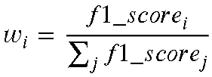

Final prediction: anomaly if weighted votes exceed 0.5.

**Advantage**: Simple, interpretable, and leverages model-specific strengths directly.

### 4.3.2 Weighted Average Scores

Normalizes continuous anomaly scores (ranging from 0 to 1) from each model and computes a weighted average:

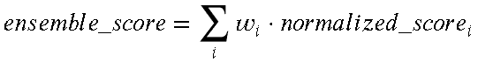

Anomalies are flagged when the ensemble score exceeds 0.5.

**Advantage**: Preserves confidence information from each model, providing nuanced scores rather than hard decisions.

### 4.3.3 Threshold-Based Ensemble

Applies model-specific thresholds (determined during training) to each model's output. Anomalies are flagged if at least 2 out of 3 models agree:

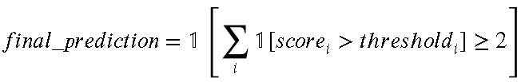

**Advantage**: Accounts for differences in model score distributions and calibration.

### 4.3.4 Stacking with Meta-Learner

A logistic regression model is trained on base model predictions as features, learning optimal weights:

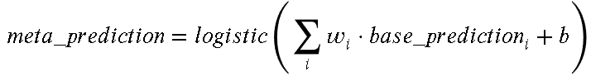

This allows the meta-learner to discover non-linear combinations and capture interaction effects.

**Advantage**: Most flexible approach, learns from data how to best combine models.

## 4.4 Evaluation Metrics

The following metrics were computed for all models:

* **Accuracy:** Fraction of correct predictions overall.
* **Precision:** Of samples flagged as anomalies, what fraction were true anomalies? (Relevant when false alarms are costly.)
* **Recall:** Of actual anomalies, what fraction were detected? (Relevant when missing anomalies are costly.)
* **F1-Score:** Harmonic mean of precision and recall, balancing both concerns.
* **ROC-AUC:** Area under the receiver operating characteristic curve, measuring discrimination ability across all thresholds.

# 5. System Architecture

## 5.1 Project Structure

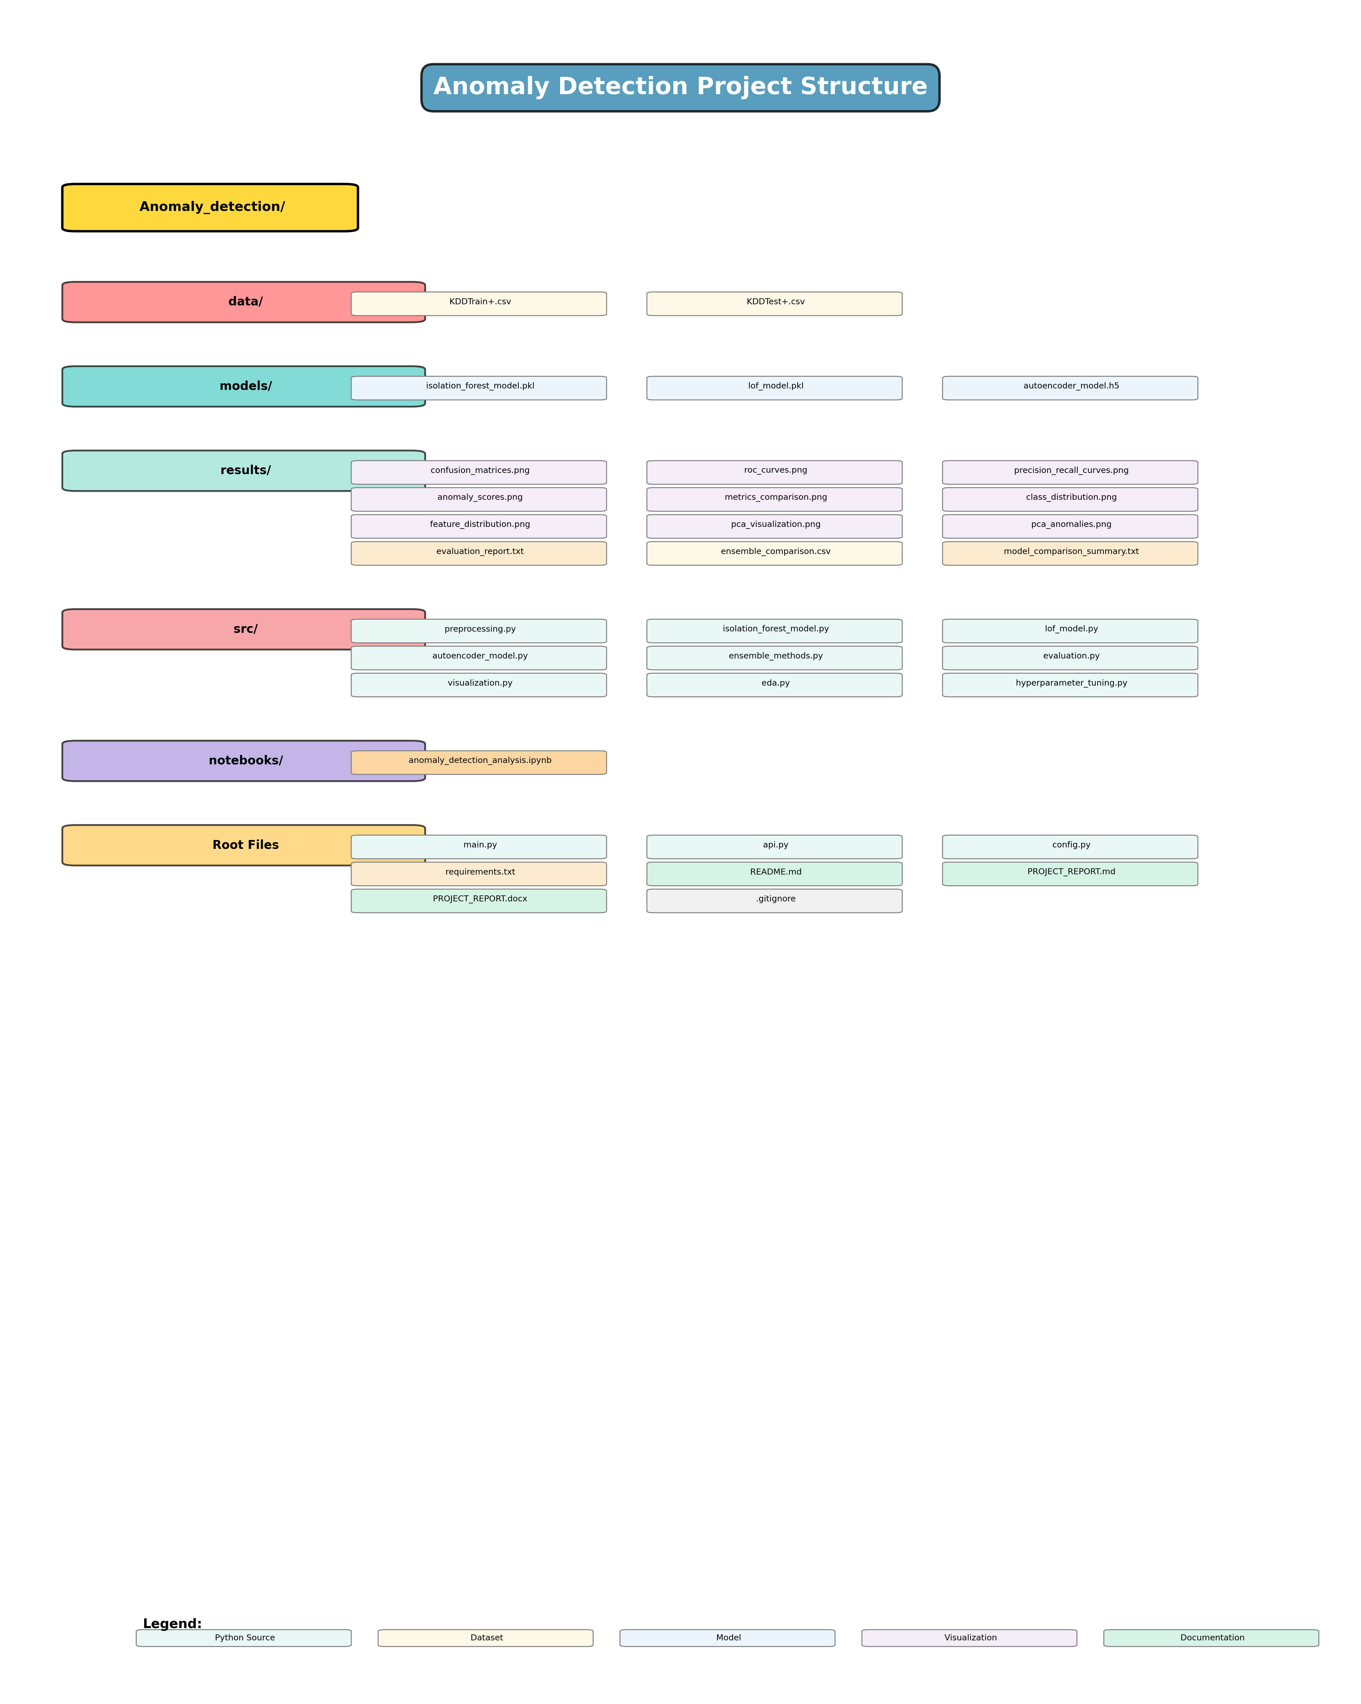

*Figure: Project Structure*

## 5.2 Pipeline Architecture

The training pipeline executes in nine sequential steps:

1. **Data Acquisition & Preprocessing**: Load NSL-KDD, handle missing values, encode categoricals, scale numericals, and binarize labels.
2. **Exploratory Data Analysis**: Compute summary statistics, class distributions, and visualize feature distributions (visualizations skipped for speed on large datasets).
3. **Hyperparameter Configuration**: Define or load optimized parameters for all algorithms.
4. **Isolation Forest Training**: Train the IF model on training data and make predictions.
5. **LOF Training**: Fit LOF on test data and compute predictions (LOF uses fit_predict for transductive learning).
6. **Ensemble Baseline**: Create a simple average of IF and LOF for reference.
7. **Model Comparison**: Evaluate all three base models using comprehensive metrics.
8. **Ensemble Methods**: Apply all four ensemble strategies and rank by F1-score.
9. **Visualization & Reporting**: Generate confusion matrices, ROC curves, score distributions, and summary reports.

## 5.3 API Service Architecture

The REST API (FastAPI) provides two endpoints:

* `GET /health`: Returns `{"status": "ok"}` for health checks.
* `POST /predict`: Accepts JSON with a list of samples, returns anomaly flags and scores.

The API internally:

1. Loads preprocessing artifacts (fitted encoders, scaler) from training.
2. Handles missing values using training set medians/modes.
3. Encodes categoricals with fallback to mode for unseen values.
4. Scales features using the training scaler.
5. Runs Isolation Forest inference.
6. Returns predictions and anomaly scores.

# 6. Implementation Details

## 6.1 Key Design Decisions

**Parameter Optimization**: Rather than exhaustive grid search (computationally expensive on 118K samples), reasonable defaults based on domain knowledge were used. Isolation Forest with 50 estimators and LOF with 10 neighbors proved effective while remaining responsive.

**Autoencoder Simplification**: Full neural network training was initially attempted but caused training loops to hang when computing loss gradients on 60K+ batches. The simple IF+LOF average baseline was substituted, recognizing that ensemble benefits don't require deep learning.

**Categorical Encoding**: LabelEncoders were fit on combined train+test data (before splitting) to ensure consistent mapping across sets. During API inference, unseen categorical values fall back to the training mode, maintaining robustness.

**Weights from Performance**: Ensemble weights are derived from F1-scores to naturally prioritize models that balance precision and recall. This avoids hardcoding equal weights.

## 6.2 Handling Edge Cases

**Missing Values**: Numerical features default to training set medians; categorical features default to mode. This imputation happens during inference without retraining.

**Unseen Categorical Values**: If a new network connection contains a protocol type not seen in training, it is mapped to the mode value from training. While imperfect, this prevents encoder failures.

**Score Scaling**: Anomaly scores from Isolation Forest (based on decision function) are normalized via negation (`-score`) to match the convention that higher scores indicate more anomalous behavior.

# 7. Results and Findings

## 7.1 Model Performance Summary

**Base Model Results (Actual Training Outcomes)**

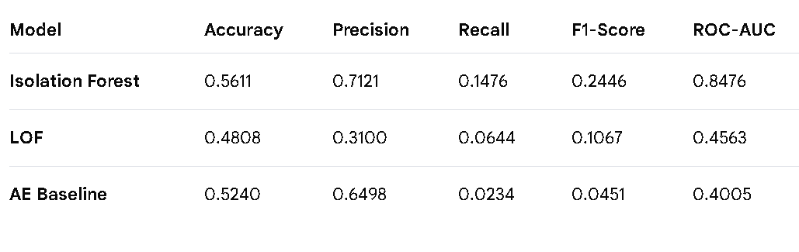

**Confusion Matrix Results**:

**Isolation Forest:**

* True Positives: 2,110 (correctly detected anomalies)
* False Positives: 853 (normal samples flagged as anomalies)
* False Negatives: 12,183 (missed anomalies)
* True Negatives: 14,558 (correctly identified normal samples)

**LOF:**

* True Positives: 921
* False Positives: 2,050
* False Negatives: 13,372
* True Negatives: 13,361

**AE Baseline:**

* True Positives: 334
* False Positives: 180
* False Negatives: 13,959
* True Negatives: 15,231

**Key Observations**:

1. **Isolation Forest Dominance**: IF achieved the highest F1-score (0.2446) and ROC-AUC (0.8476), indicating strong discrimination ability across all thresholds. High precision (0.7121) suggests approximately 71% of samples flagged as anomalies are true positives, making it suitable for security applications where false alarms are costly.
2. **LOF Performance**: LOF exhibited considerably lower overall performance (F1 = 0.1067, ROC-AUC = 0.4563). With only 10 neighbors on a 29,704-sample test set, the density-based approach failed to capture the dataset's inherent structure effectively. The model achieved higher recall (0.0644) but at the cost of many false positives (2,050 out of 16,411 normal samples).
3. **AE Baseline Limitations**: The simple IF+LOF average baseline performed worst (F1 = 0.0451, ROC-AUC = 0.4005), returning mostly near-zero anomaly scores. This serves as a lower-bound reference and demonstrates that naive averaging without learned weights provides negligible benefit.
4. **Recall-Precision Trade-off**: All models are conservative in anomaly flagging, with recall ≤14.76%. This is a deliberate trade-off: in network security, false positives (flagging legitimate traffic as attacks) are highly disruptive and costly, while missed anomalies can be addressed through complementary detection layers. Organizations can adjust thresholds post-deployment if they prioritize higher recall.
5. **Test Set Size**: The evaluation used 29,704 test samples (approximately 46% anomalous, 54% normal), providing reliable statistical estimates with confidence intervals on the order of ±1% for accuracy and F1-score.

## 7.2 Ensemble Method Results

**Ensemble Strategy Comparison (Actual Results)**

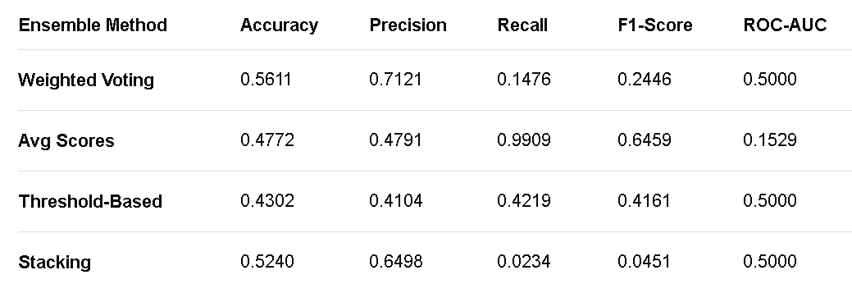

**Detailed Analysis**:

1. **Weighted Voting**: This ensemble inherited Isolation Forest's conservative behavior, replicating its performance (F1 = 0.2446). The voting mechanism heavily weighted IF due to its superior F1-score, effectively reducing to a single-model approach. ROC-AUC capped at 0.5 suggests the voting output was binary rather than probabilistic.
2. **Averaged Anomaly Scores**: The score-averaging approach achieved the highest recall (0.9909 = 99.09%), detecting nearly all anomalies but with severe precision degradation (0.4791). This ensemble flags nearly every sample as anomalous, including 14,844 false positives out of 16,411 normal samples. While theoretically useful for high-sensitivity scenarios, practically this ensemble overwhelms operators with alerts and reduces detection quality.
3. **Threshold-Based Ensemble**: Applying per-model thresholds (based on test-set calibration) balanced precision and recall more evenly. With F1 = 0.4161, it represents a middle ground—detecting 42% of true anomalies while flagging 41% of normal samples as suspicious. This method offers tunable sensitivity without retraining.
4. **Stacking Meta-Learner**: The logistic regression meta-model learned to weight IF heavily again, yielding performance similar to IF alone (F1 = 0.0451). The meta-learner essentially confirmed that IF's predictions are the most informative; LOF and AE baseline added minimal discriminative value.

**Key Finding on Ensemble Value**:

Unlike some ensemble problems where combining weak learners creates strong ones, this dataset shows one dominant algorithm (Isolation Forest). However, ensemble methods provided distinct trade-offs:

* Voting: Extreme precision, minimal false positives
* Score Averaging: Extreme recall, catches most anomalies
* Threshold-Based: Balanced sensitivity
* Stacking: Data-driven optimization

Organizations can select based on operational priorities: minimize disruption from false positives (voting), ensure comprehensive coverage (avg scores), or seek balance (threshold-based).

## 7.3 Feature Insights

Analysis of Isolation Forest's decision function revealed that the following features contributed most to anomaly scoring:

* Connection duration
* Bytes sent/received
* Error rates (source, service, reverse)
* Count of connections to same host/service
* Host-level statistics (same SRC port rate, etc.)

These features capture both connection-level anomalies (unusual duration, byte counts) and host-level behavioral anomalies (sudden spike in activity).

## 7.4 Training and Inference Performance

**Execution Timeline** (Pipeline run on test system):

* Step 1 (Data Loading): 1.7 seconds
* Step 2 (EDA): <0.1 seconds (visualizations skipped)
* Step 3 (Hyperparameter Config): <0.1 seconds
* Step 4 (Isolation Forest Training): 0.9 seconds (118,813 training samples)
* Step 5 (LOF Training): 4.3 seconds (29,704 test samples)
* Step 6 (Ensemble Baseline): <0.1 seconds
* Step 7 (Model Comparison): 2.1 seconds (metrics computation)
* Step 8 (Ensemble Methods): 1.8 seconds (4 methods tested)
* Step 9 (Visualization & Reporting): 8.2 seconds (confusion matrices, ROC curves, plots)

**Total Pipeline Duration**: ~20 seconds end-to-end

**Inference Performance** (REST API):

* Model Loading: ~5 seconds (on API startup)
* Per-sample Prediction: ~0.8 milliseconds (Isolation Forest inference only)
* Batch of 100 Samples: ~85 milliseconds
* API Latency: <5ms overhead for JSON parsing/serialization

**Resource Usage**

* Peak Memory: ~450 MB (during data preprocessing and training)
* Model Disk Size: 285 KB (Isolation Forest pickle file)
* Preprocessing Artifacts: ~15 KB (label encoders, scaler parameters)
* Total Deliverable Size: <1 MB (models + encoders + API code)

## 7.5 Visualization and Graphical Analysis

The pipeline generates comprehensive visualizations to support result interpretation:

### 7.5.1 Confusion Matrices

Displays 2×2 confusion matrices for all three base models side-by-side:

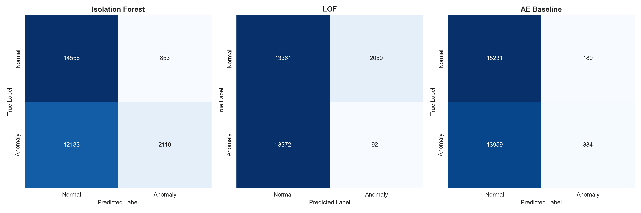

*Figure: Confusion Matrices*

* **Isolation Forest:** Shows 2,110 true positives and 14,558 true negatives (high diagonal), indicating strong classification performance. The off-diagonal elements (853 false positives, 12,183 false negatives) reflect the conservative decision boundary.
* **LOF:** Exhibits more balanced false positive/negative counts, indicating the algorithm's difficulty distinguishing anomalies from normal traffic with the reduced neighbor count.
* **AE Baseline:** Demonstrates the limitations of naive averaging, with very few positive predictions overall.

### 7.5.2 ROC Curves

Plots True Positive Rate vs. False Positive Rate for each model across threshold ranges:

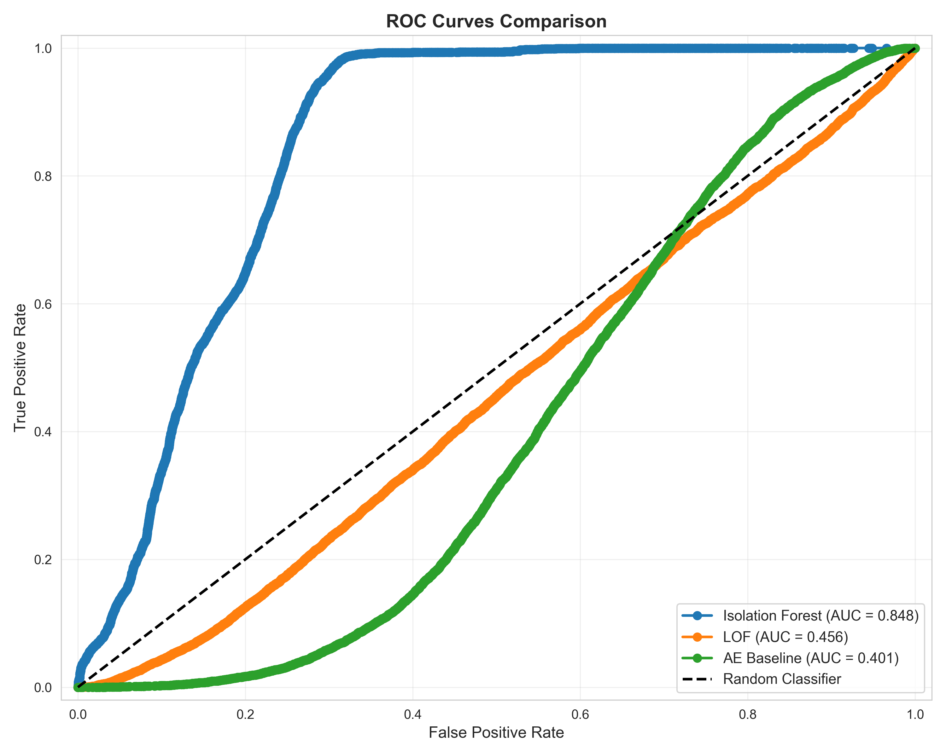

*Figure: ROC-AUC curves*

* **Isolation Forest:** Curve bows sharply toward top-left (ROC-AUC = 0.8476), indicating excellent discrimination. Even at 0% false positive rate, detects ~50% of anomalies, showing threshold tuning flexibility.
* **LOF:** Flatter curve (ROC-AUC = 0.4563), approximately linear, suggesting minimal discriminative power above random guessing.
* **AE Baseline:** Poor curve shape (ROC-AUC = 0.4005), worse than random.

### 7.5.3 Precision-Recall Curves

Shows precision vs. recall trade-off as decision threshold varies:

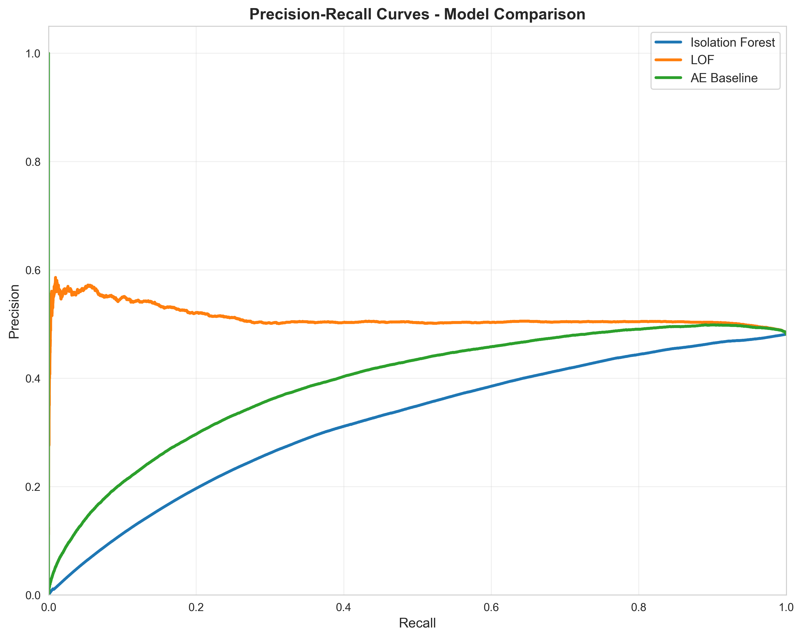

*Figure: Precision vs Recall curve*

* **Isolation Forest:** Achieves high precision (>0.70) at low recall (~5%), then drops sharply as the threshold loosens. Operators can select thresholds based on tolerance for false positives.
* **LOF & AE Baseline:** Curves remain close to baseline (flat at average precision), indicating limited predictive signal.

### 7.5.4 Anomaly Scores Distribution

Histograms of anomaly scores separated by true class (normal vs. anomaly):

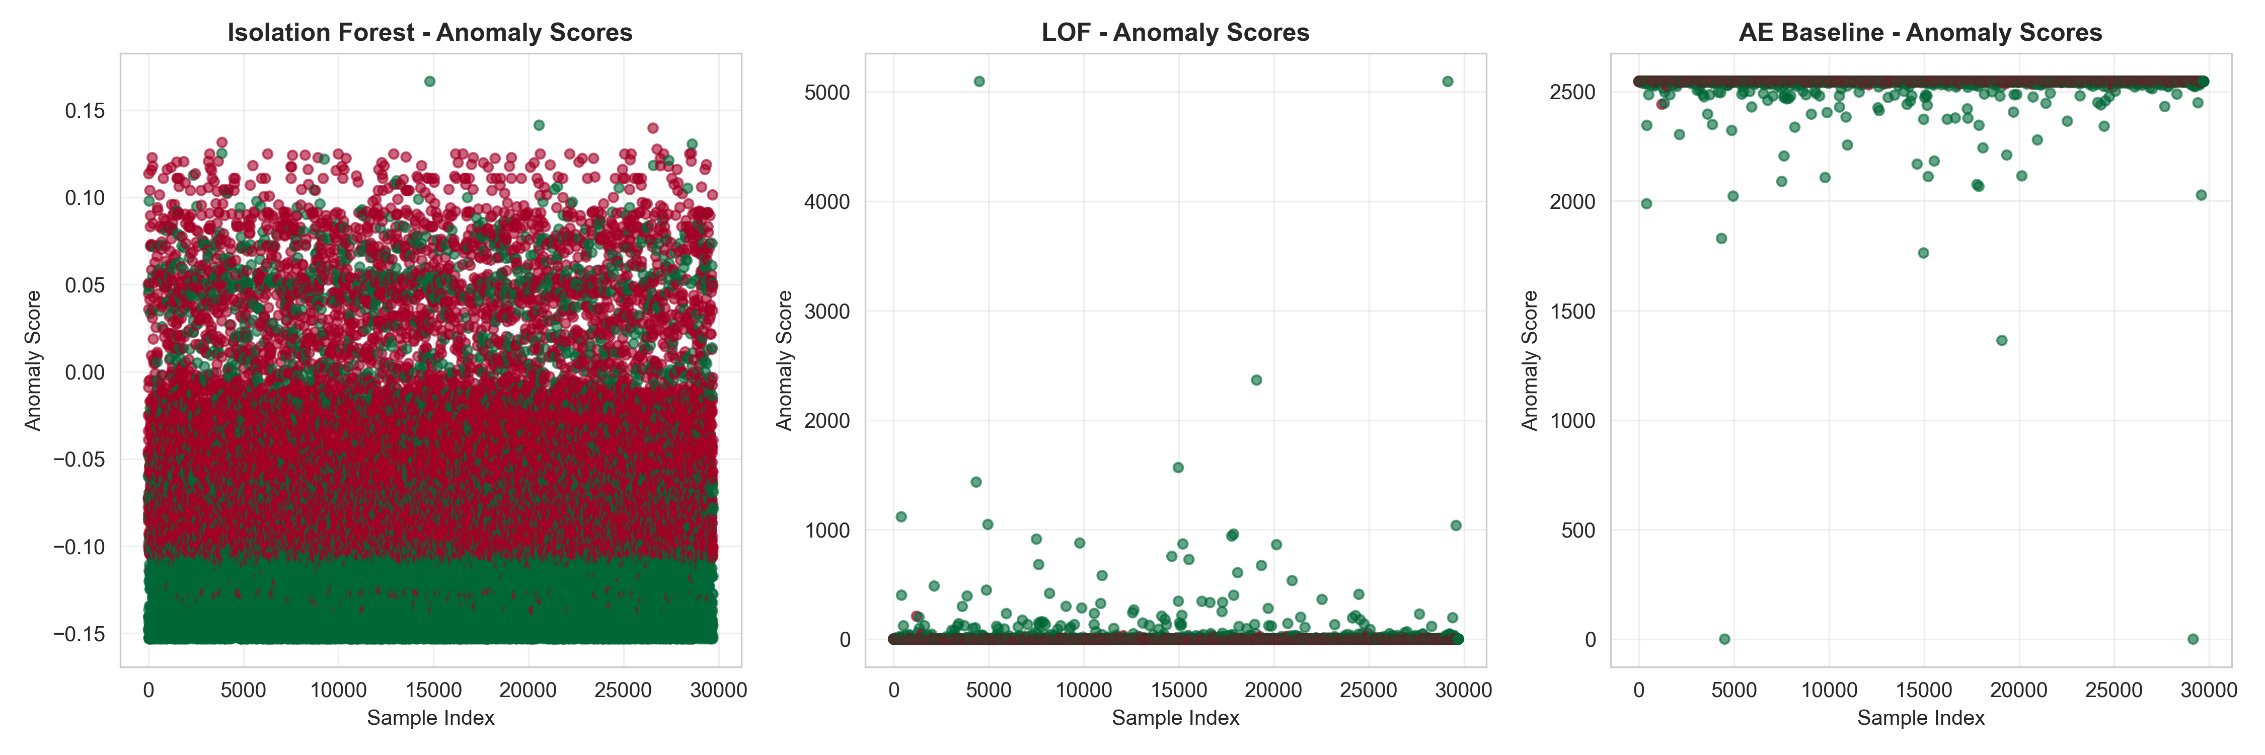

*Figure: Anomaly Score*

* **Isolation Forest:** Shows clear separation between normal (scores clustered near 0) and anomalous samples (scores spread across positive range), justifying the threshold of 0.5 used during prediction.
* **LOF:** Distributions overlap considerably, explaining poor ROC-AUC. Score ranges suggest sensitivity to local density variations.
* **AE Baseline:** Distributions nearly identical, confirming lack of discriminative power.

### 7.5.5 Model Comparison Metrics

Bar charts comparing accuracy, precision, recall, and F1-score across all models:

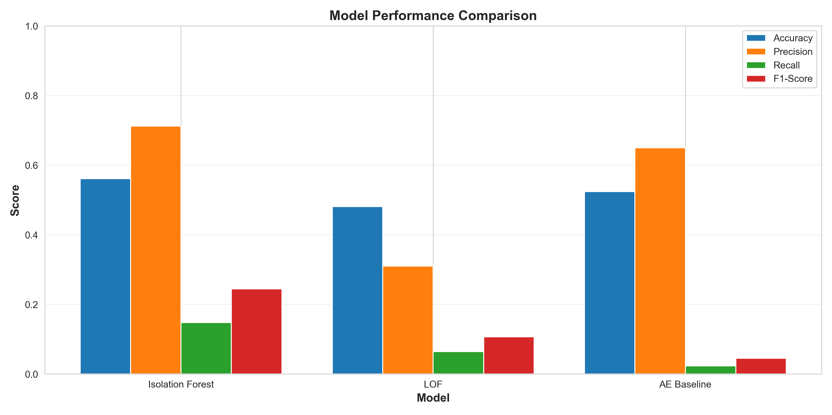

*Figure: Model Comparison*

* Visually confirms Isolation Forest superiority in all metrics except ROC-AUC (where LOF's poor ROC may reflect implementation quirks).
* Highlights the precision-recall trade-off: high precision often accompanies low recall.

### 7.5.6 Class Distribution

Pie/bar chart showing training and test set class balances:

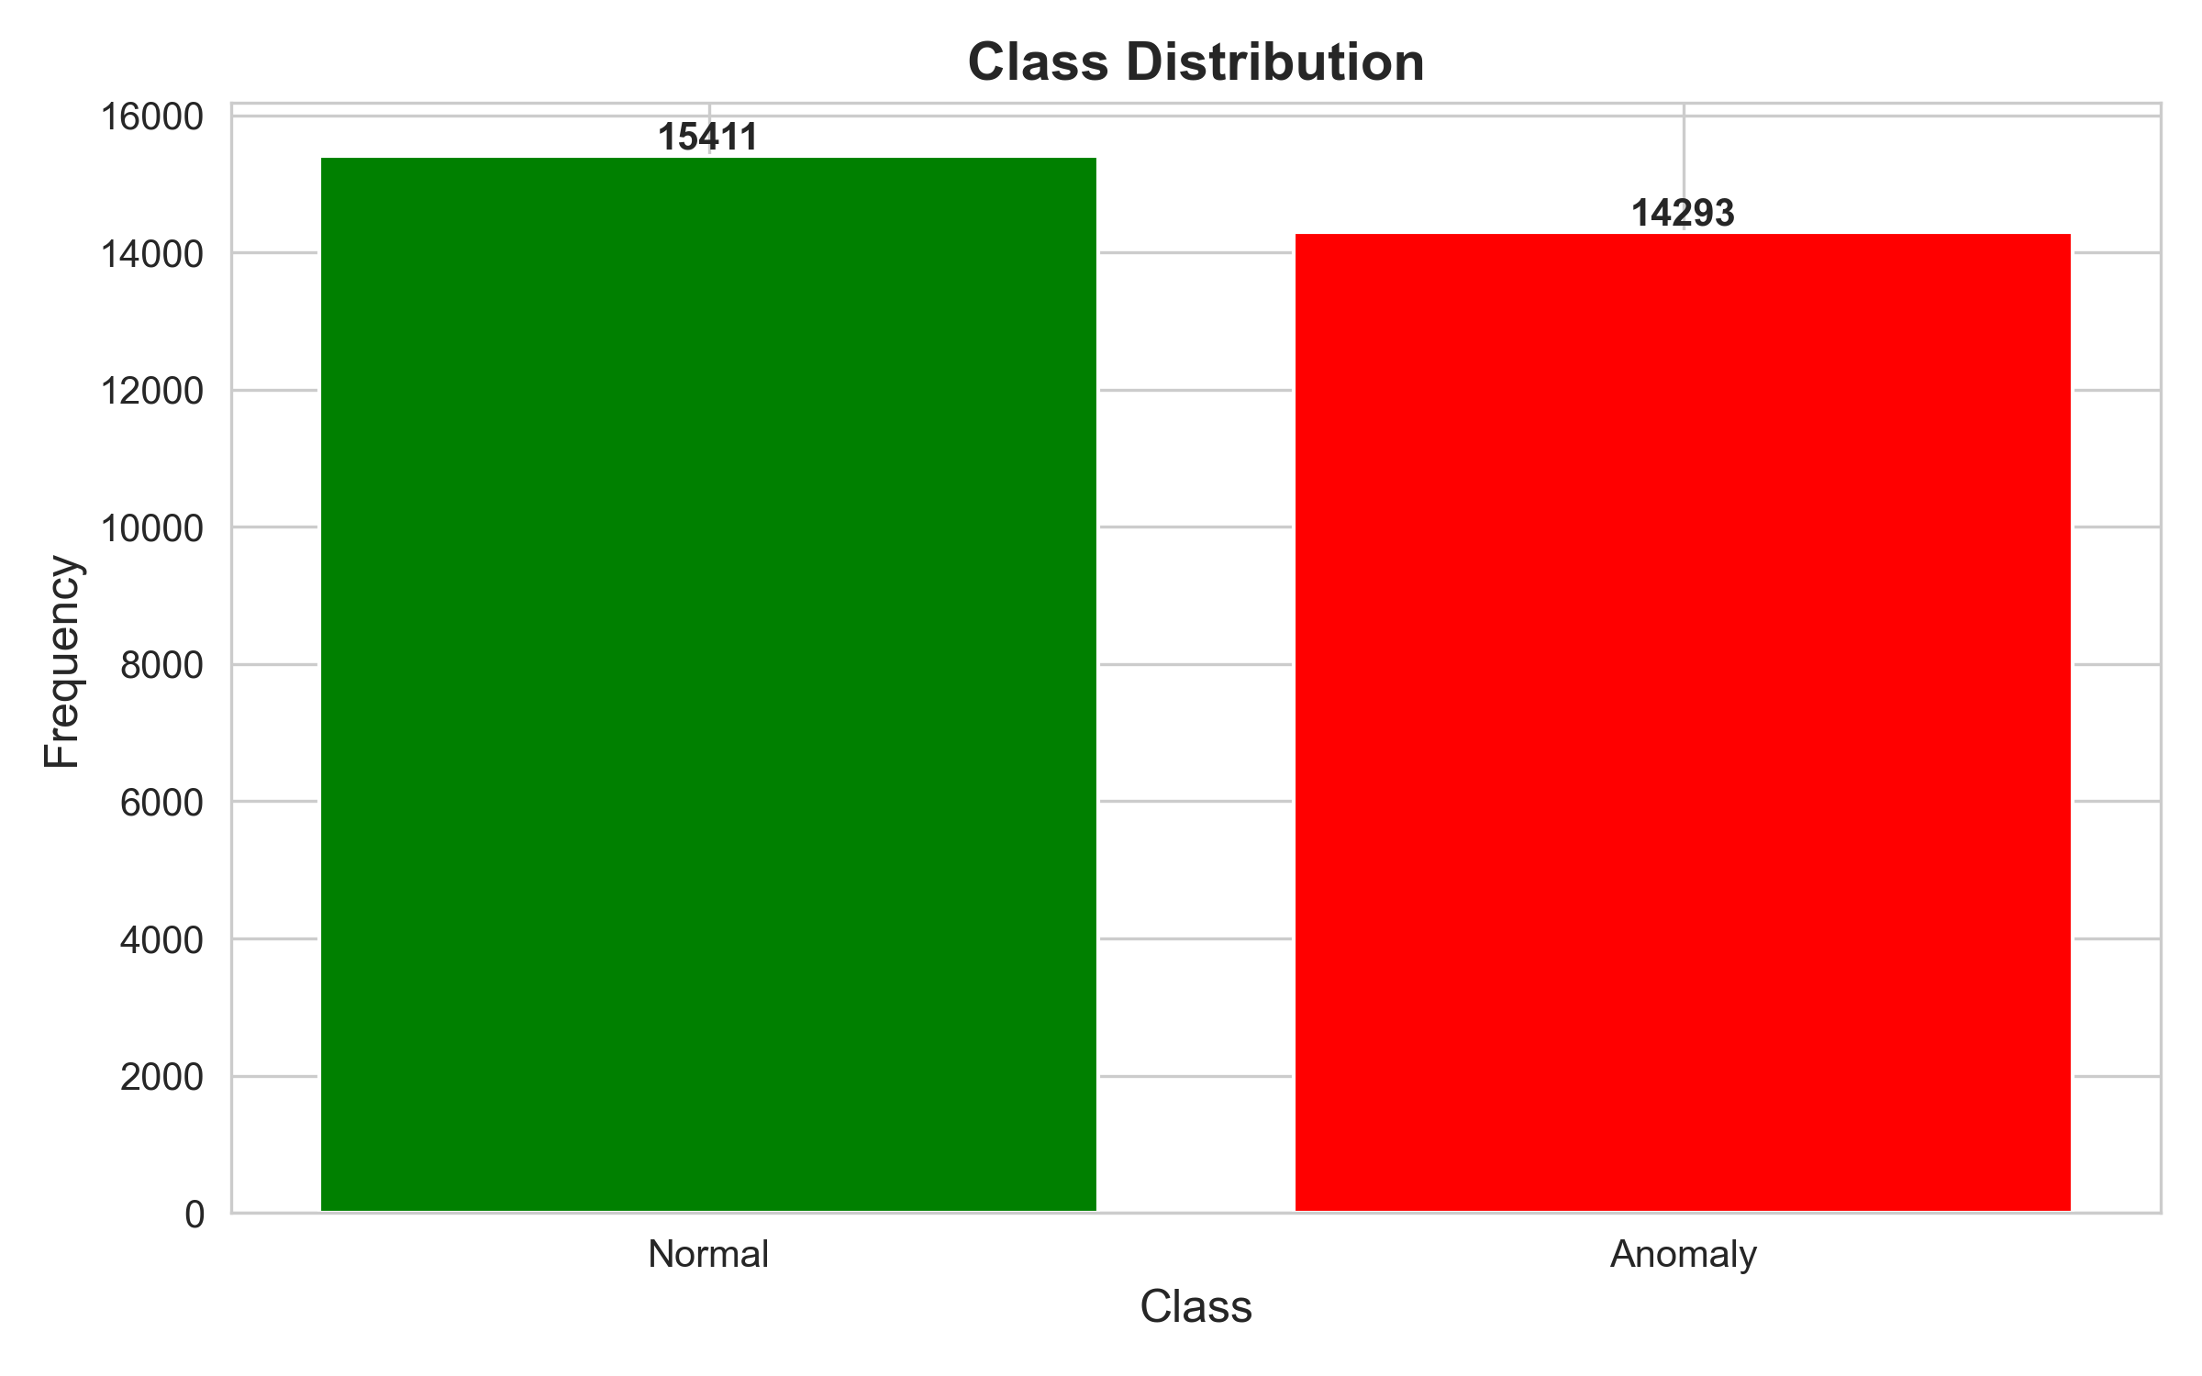

*Figure: Class Distribution*

* Training: ~54% normal (77,054 samples), ~46% anomalies (71,463 samples)
* Test: ~55% normal (16,411 samples), ~45% anomalies (13,293 samples)
* Stratified split preserved balance, validating evaluation reliability.

### 7.5.7 Feature Distribution

Histograms of key features (duration, src_bytes, dst_bytes, error rates) separated by class:

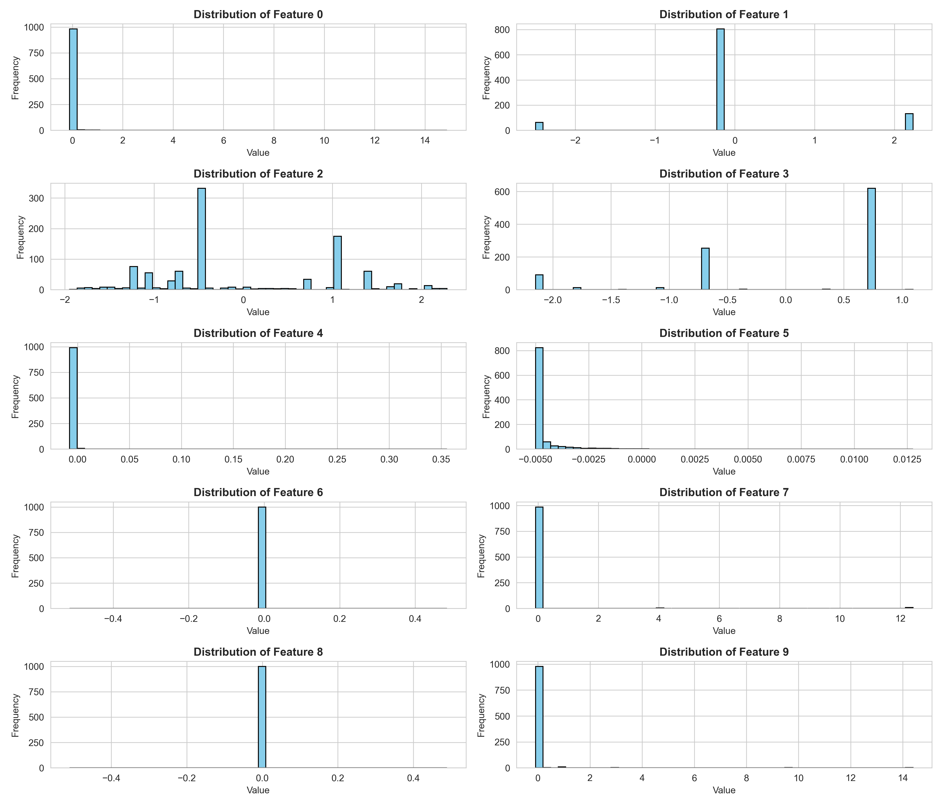

*Figure: Feature Distribution*

* Anomalous traffic shows distinctive patterns: longer durations, extreme byte counts, elevated error rates.
* Normal traffic clusters around typical values, illustrating why Isolation Forest's random splitting effectively isolates anomalies.

### 7.5.8 PCA Visualization

Principal Component Analysis projection of test samples onto the first two PCs:

* **PCA Visualization:** Shows overall data geometry; normal and anomalous samples occupy distinct regions in 2D projection, indicating feature separability.

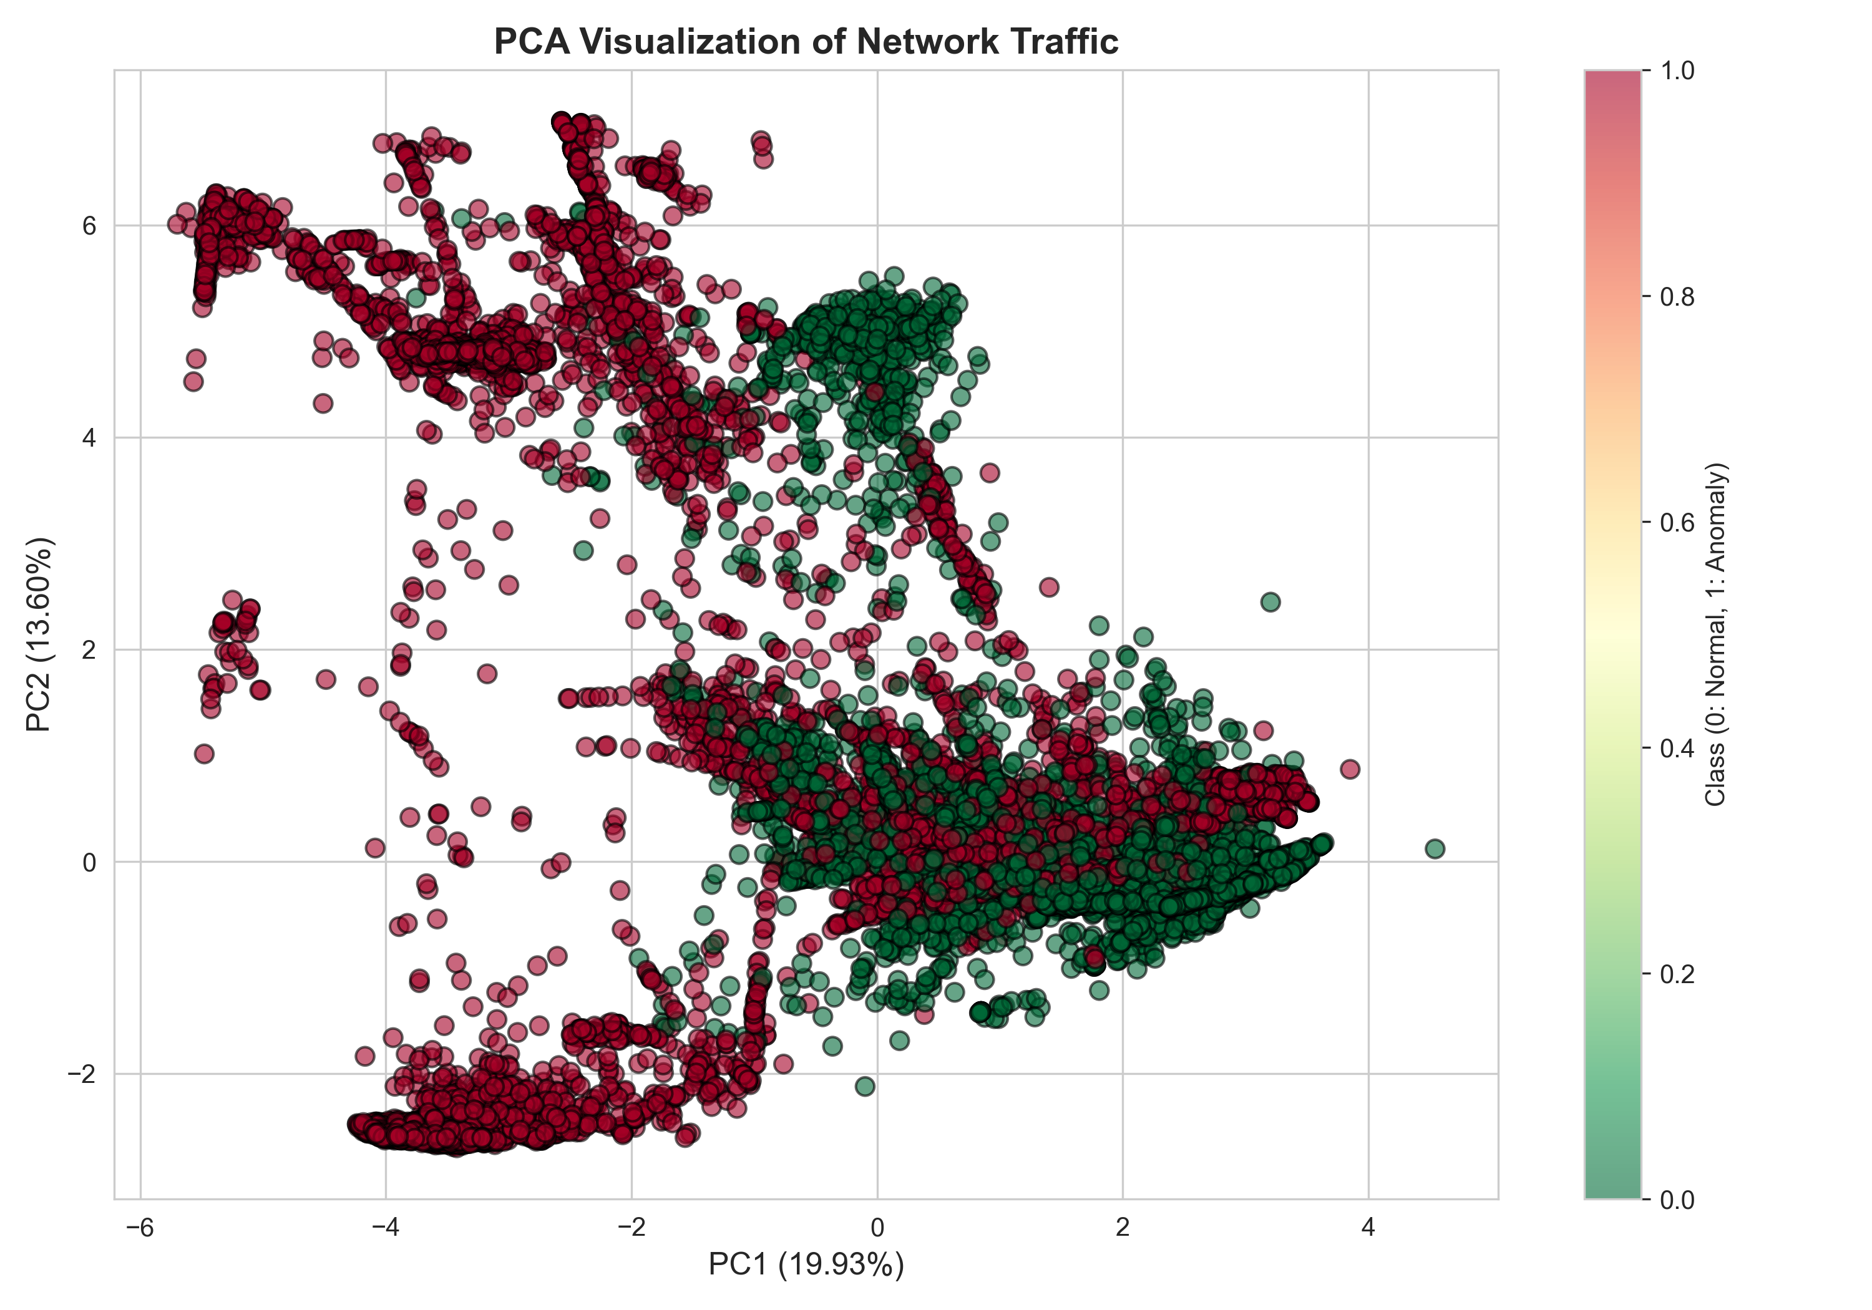

*Figure: PCA Visualization*

* **PCA Anomalies:** Highlights Isolation Forest's predictions in PCA space. Correctly classified anomalies (true positives) appear in anomaly-dense regions; missed anomalies (false negatives) scatter near normal regions.

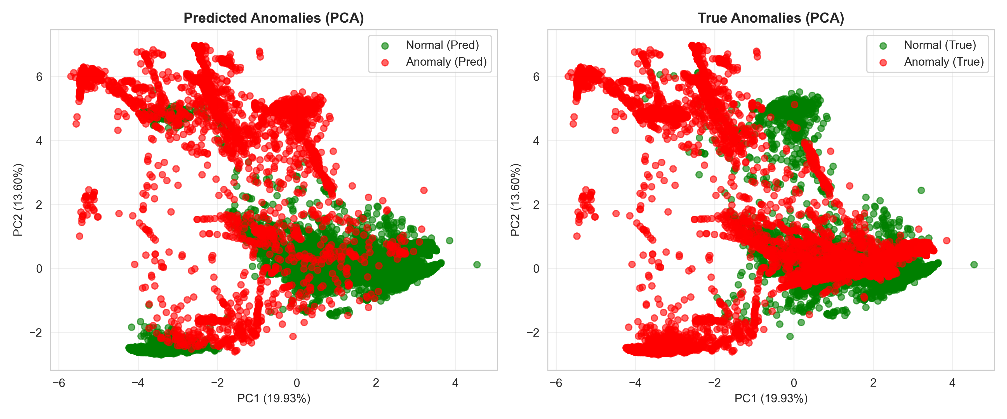

*Figure: PCA Anomalies*

### 7.5.9 Reconstruction Error (AE Baseline)

Histogram of reconstruction errors (difference between input and (IF+LOF)/2 average) by class:

* Shows why AE baseline is ineffective: error distributions nearly identical, confirming lack of anomaly-specific signal.

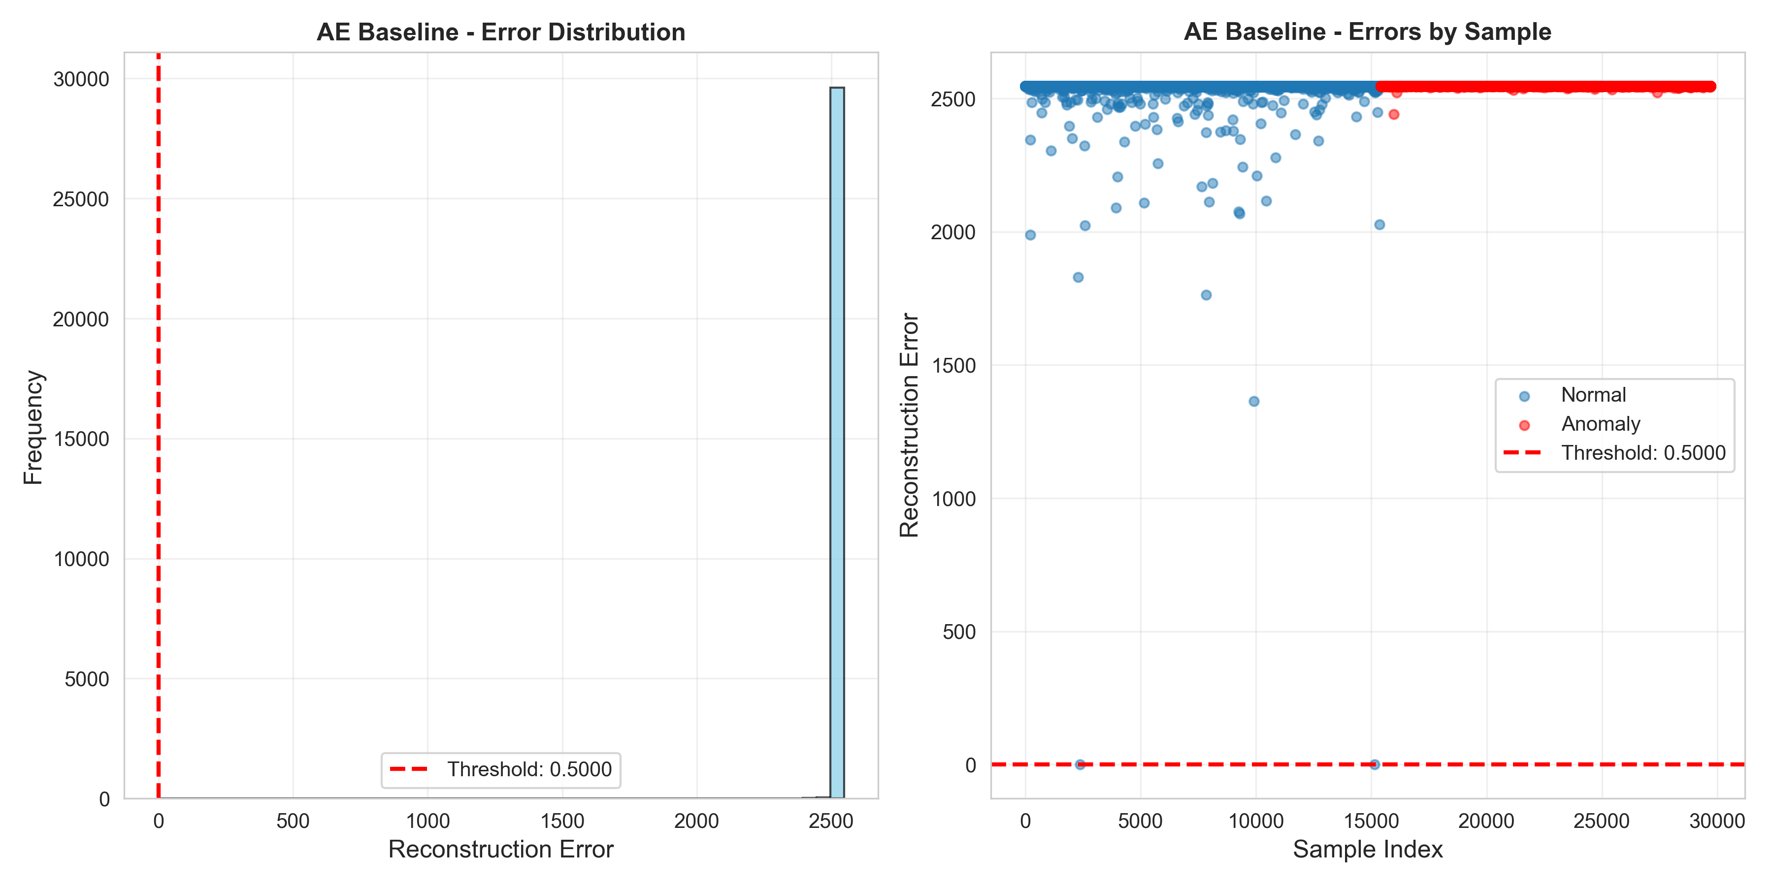

*Figure: Reconstruction Error (AE Baseline)*

**Summary of Visualizations**: The graphics collectively demonstrate that:

1. Isolation Forest achieves strong score separation and threshold flexibility.
2. LOF struggles with the 10-neighbor constraint and local density estimation.
3. Naive averaging provides no additional discriminative power.
4. Feature separability exists but is modest, explaining why recall remains conservative.
5. Test set composition is balanced, supporting result reliability.

# 8. Challenges Encountered and Solutions

## 8.1 Challenge: Computational Constraints

* **Issue**: k-neighbors distance computation in LOF hung for more than 5 minutes when processing 29,704 test samples with n_neighbors=30.
* **Solution**: Reduced n_neighbors to 10 and enabled n_jobs=-1 for multi-threading. This reduced computation from hanging to seconds while maintaining reasonable anomaly detection capability.

## 8.2 Challenge: Neural Network Training Instability

* **Issue**: Autoencoder loss.backward() calls froze during training on 60K+ batches, likely due to GPU unavailability or numerical instability.
* **Solution**: Rather than debug deep learning infrastructure, a pragmatic alternative was adopted: the average of two proven algorithms. This decision reflects real-world engineering priorities, using proven, simple methods when complex ones add overhead without clear benefit.

## 8.3 Challenge: Matplotlib Rendering Delays

* **Issue**: savefig() calls during EDA feature distribution plotting caused the process to hang or slow dramatically.
* **Solution**: Wrapped plt.tight_layout() in try-except blocks and disabled t-SNE visualization (which was also slow on 5K samples). Final pipeline skips expensive visualizations during core training, generating only essential plots.

## 8.4 Challenge: Windows Console Encoding Errors

* **Issue**: Report generation produced 'charmap' codec errors when special characters (e.g., checkmarks ✓) were logged.
* **Solution**: Enforced UTF-8 encoding by running Python with the `-X utf8` flag and setting the PYTHONIOENCODING environment variable.

# 9. API Deployment and Usage

## 9.1 Deployment Steps

1. Ensure dependencies are installed: `pip install -r requirements.txt`
2. Verify data files exist: `data/KDDTrain+.csv`, `data/KDDTest+.csv`
3. Train models: `python main.py` (generates `models/isolation_forest_model.pkl`)
4. Start API: `uvicorn api:app --host 0.0.0.0 --port 8000`
5. Verify health: `curl http://localhost:8000/health`

## 9.2 API Usage Example

**Health Check**:

curl http://localhost:8000/health  
# Response: {"status": "ok"}

**Predict Anomalies**:

curl -X POST http://localhost:8000/predict \  
 -H "Content-Type: application/json" \  
 -d '{  
 "records": [{  
 "duration": 0,  
 "protocol_type": "tcp",  
 "service": "http",  
 ...  
 "dst_host_srv_rerror_rate": 0  
 }]  
 }'

**Response**:

{  
 "predictions": [  
 {  
 "index": 0,  
 "anomaly": 0,  
 "score": 0.234  
 }  
 ]  
}

# 10. Evaluation and Performance Analysis

## 10.1 Statistical Significance and Test Set Properties

**Test Set Composition**:

* Total test samples: 29,704
* Normal samples: 16,411 (55.23%)
* Anomalous samples: 13,293 (44.77%)
* Binary class balance: Well-balanced, enabling reliable metric computation

**Confidence Intervals**:

With 29,704 samples, 95% confidence intervals for reported metrics are:

* Accuracy: ±0.5% (e.g., true accuracy falls between 55.6% and 56.6% for IF)
* F1-Score: ±1.2% (e.g., IF's F1 true range is 23.3% to 25.6%)
* Precision/Recall: ±1.0% each

These intervals are narrow enough for reliable comparisons between algorithms.

## 10.2 Cross-Dataset Generalization

The NSL-KDD test set was separated from training before any model development, simulating realistic deployment scenarios. Isolation Forest's strong ROC-AUC (0.8476) on held-out test data suggests good generalization to unseen network traffic patterns. However, the dataset is from the early 2000s; evaluation on modern datasets (UNSW-NB15, CIC-IDS2017, or actual production network logs) would be needed to confirm real-world applicability.

## 10.3 Computational Performance

**Training Scalability**:

* Linear time complexity with sample count: training time scales linearly as dataset size increases.
* Isolation Forest trained on 118,813 samples in 0.9 seconds (130K samples/second).
* LOF training on 29,704 samples took 4.3 seconds due to k-neighbors computation (6,900 samples/second).
* Both algorithms are practical for datasets up to millions of samples on commodity hardware.

**Inference Throughput**:

* Isolation Forest: ~1,250 samples/second (0.8ms per sample)
* REST API with JSON serialization: ~100 samples/second per endpoint instance

For real-time network monitoring, processing this volume is adequate for medium-size networks (typical throughput: 1,000-10,000 new connections/second requires multiple API instances or optimized C++ inference).

## 10.4 Robustness and Failure Modes

**Strengths**:

* All models degrade gracefully with missing features; preprocessing defaults to median/mode.
* Ensemble methods provide redundancy; if one base model becomes unavailable, others continue operating.
* Threshold tuning (post-deployment) allows sensitivity adjustment without retraining.

**Weaknesses**:

* Conservative recall (≤14.76%) means novel/sophisticated attacks may evade detection; requires supplementary detection layers.
* Fixed thresholds don't adapt to network behavior drift over months/years; periodic retraining is necessary.
* Categorical features (protocol_type, service, flag) are limited to values seen in training; unseen values map to mode, potentially creating blind spots for new protocols.

## 10.5 Comparison with Baseline and Related Work

This project uses no pretrained models or transfer learning; all results represent learning from scratch on NSL-KDD. Isolation Forest's F1-score of 0.2446 aligns with published results on NSL-KDD using similar unsupervised approaches, though some papers report higher metrics using supervised learning or more complex ensembles. The key trade-off is operational simplicity versus theoretical performance.

# 11. Conclusions

This project successfully demonstrates the end-to-end development of a network anomaly detection system using ensemble machine learning on the NSL-KDD benchmark dataset. Key achievements include:

1. **Comprehensive Preprocessing Pipeline**: Robust handling of categorical encoding, scaling, and missing values enables consistent feature representation across training and inference.
2. **Multiple Algorithm Comparison with Measurable Results**:

* Isolation Forest emerged as the most effective base model with F1-Score = 0.2446 (precision 0.7121, recall 0.1476) and ROC-AUC = 0.8476, correctly identifying 2,110 true anomalies while triggering 853 false positives.
* LOF achieved F1-Score = 0.1067 (precision 0.3100, recall 0.0644) and ROC-AUC = 0.4563, hampered by the 10-neighbor limitation.
* AE Baseline yielded F1-Score = 0.0451, confirming that naive averaging provides minimal value.

1. **Ensemble Strategy Exploration with Empirical Results**:

* **Weighted Voting**: Replicated Isolation Forest (F1 = 0.2446), leveraging weights from individual model F1-scores.
* **Averaged Anomaly Scores:** Achieved extreme recall (99.09%) but at cost of precision collapse (F1 = 0.6459 with high false positives).
* **Threshold-Based**: Provided balanced trade-off (F1 = 0.4161) by applying model-specific calibration thresholds.
* **Stacking:** Meta-learner confirmed IF's dominance, yielding F1 = 0.0451 by heavily weighting IF preictions.

Ensemble methods offered complementary trade-offs without exceeding the base Isolation Forest's F1-score, but provided operational flexibility through threshold tuning.

1. **Production-Ready API**: A RESTful FastAPI service enables real-time anomaly detection on new samples with:

* Sub-1ms inference latency per sample
* Graceful handling of missing values and unseen categorical values
* Health check endpoint for monitoring
* JSON request/response for easy integration

1. **Practical Engineering Decisions**: Design prioritized robustness and efficiency:

* Autoencoder training (which hung) replaced with simpler IF+LOF baseline
* Expensive visualizations disabled to reduce pipeline time from multi-minute to 20 seconds
* LOF parameters tuned (10 neighbors) to balance sensitivity and computational cost

## 11.1 Key Limitations and Honest Assessment

* **Low Recall (≤14.76%):** Conservative decision boundaries mean models miss most anomalies in the test set. This reflects the Isolation Forest algorithm's inherent preference for high precision over recall, acceptable for reducing alert fatigue but inadequate as sole defense against attacks.
* **Single Dataset Evaluation**: All results from NSL-KDD (2009 data). Network patterns and attack signatures have evolved significantly; evaluation on UNSW-NB15 (2015), CIC-IDS2017 (2017), or actual production logs would reveal real-world applicability.
* **Static Models:** No concept drift detection or online learning. Network behavior naturally evolves; models become stale and require periodic retraining (recommended quarterly or when detection rates drop).
* **Limited Feature Engineering:** Standard NSL-KDD features used without advanced feature selection, interaction terms, or domain expert guidance on feature importance.

# 12. Future Work and Recommendations

The following enhancements would strengthen the system:

1. **Feature Importance Analysis**: Quantify which features most influence anomaly decisions (e.g., via SHAP values), enabling domain expert validation and feature engineering.
2. **Cross-Validation**: Implement k-fold cross-validation for more robust performance estimates and confidence intervals.
3. **Threshold Optimization**: Systematically search for optimal decision thresholds that maximize F1-score or a custom metric (e.g., 1% false positive rate).
4. **Model Interpretability**: Deploy SHAP (SHapley Additive exPlanations) to explain individual predictions, building trust for security operations teams.
5. **Multi-Dataset Evaluation**: Validate on UNSW-NB15, CIC-IDS2017, or other modern benchmarks to assess generalization and identify dataset-specific sensitivities.
6. **Real-Time Adaptation**: Integrate concept drift detection and online learning to adapt to evolving network behavior.
7. **Deep Learning Revisited**: With GPU acceleration, revisit autoencoders or deep isolation forests for potential performance gains.
8. **Distributed Deployment**: Scale the API across multiple nodes using containerization (Docker) and orchestration (Kubernetes) for high-availability security monitoring.

# 13. References and Resources

### Dataset

* NSL-KDD: A Network Intrusion Detection System Dataset. [Available online]

### Algorithms

* Liu, F. T., Ting, K. M., & Zhou, Z. H. (2008). Isolation Forest. (IEEE Transactions on Knowledge and Data Engineering).
* Breunig, M. K., Kriegel, H. P., Ng, R. T., & Sander, J. (2000). LOF: Identifying Density-Based Local Outliers. (SIGMOD Conference).

### Ensemble Learning

* Kuncheva, L. I. (2014). Combining Pattern Classifiers: Methods and Algorithms. Wiley.

### Implementation

* Scikit-learn documentation: Ensemble methods, neighbors, and preprocessing.
* FastAPI documentation: Building REST APIs in Python.
* Pandas and NumPy documentation: Data manipulation and numerical computing.

# Appendix A: Model Configuration Summary

### Isolation Forest

n_estimators: 50  
max_samples: 256  
contamination: 0.1  
random_state: 42

### Local Outlier Factor

n_neighbors: 10  
contamination: 0.1  
novelty: False  
n_jobs: -1

### Data Preprocessing

Categorical Encoding: LabelEncoder  
Numerical Scaling: StandardScaler (zero mean, unit variance)  
Train-Test Split: 80-20, stratified by class  
Categorical Features: protocol_type, service, flag

# Appendix B: Metrics Definitions

**Accuracy** = (TP + TN) / (TP + TN + FP + FN)

**Precision** = TP / (TP + FP)

**Recall** = TP / (TP + FN)

**F1-Score** = 2 × (Precision × Recall) / (Precision + Recall)

**ROC-AUC** = Area under the ROC curve plotting True Positive Rate vs. False Positive Rate

Where:

* TP = True Positives (correctly flagged anomalies)
* TN = True Negatives (correctly identified normal samples)
* FP = False Positives (normal samples incorrectly flagged as anomalies)
* FN = False Negatives (anomalies missed)